DC SRAP meeting 55
Time: 2024-12-03, 16:00-17:00 UTC
Place: Zoom, https://helsinki.zoom.us/j/62368569596?pwd=UGQxenZFbjZQUlluRzdQQUM1UFhaUT09

Agenda

Opening of the meeting

Appointment of the minutes taker - Karen

Approval of the agenda

Minutes of previous meetings
Minutes of previous meetings are on GitHub:
https://github.com/dcmi/dc-srap/tree/main/meetings

Minutes of the previous meeting 54 added by Alasdair, thanks!
https://github.com/dcmi/dc-srap/blob/main/meetings/2024-11-07_srap_meeting_54_notes.docx

Linking to PDFs and other files
GitHub issue: https://github.com/dcmi/dc-srap/issues/62

Proposed addition to the TAP: https://github.com/dcmi/dc-srap/pull/66

We did some refinement of the proposed changes in the PR at the previous meeting, but didn't merge it yet.

Minutes: Using identifier for landing page; edit done.

Taking SRAP to the DCMI Usage Board
GitHub issue: https://github.com/dcmi/dc-srap/issues/64

Osma has contacted Niklas and Tom about how to present SRAP to the Usage Board.

Niklas responded on behalf of the UB chairs (Niklas, Tom, Argie):

> 1. Does the above plan sound reasonable?

Generally yes. We do however have some questions about the "flat" expression of SRAP, not covered in your summary.

> 2. Any thoughts on how this should be presented to the UB? Should we
> open GitHub issues for some of this, for example the proposed new additions?

Using Github issues is a good idea, for example to discuss the proposed additions, also about questions related to publication of the profile and related materials.

> 3. Do you think it's realistic to propose new additions to DCTerms
> and/or BIBO, given that these namespaces have not seen significant
> changes for a long time?

We wonder why BIBO and Schema.org are both used (eg, why `schema:isbn` and not `bibo:isbn`)?

We would prefer to see specific properties added to BIBO instead of DC terms given that BIBO is already being used in SRAP; the terms to be added are at least as specific as those in BIBO (and not as "core" as DC terms) -- some arguably regrettable "grey area" ("non-core") properties in DC terms, such as accrualPolicy, notwithstanding.

> 4. What are the requirements for the documentation and other materials
> if/when DC-SRAP is going to be published on the Dublin Core website?

Good question. We could perhaps use the publication of SRAP as an occasion to draft a template or checklist about publishing profiles generally.

In the main [SRAP profile document](https://dcmi.github.io/dc-srap/srap-profile), we would want to see:

* Some characterization of requirements, if only in a paragraph or two in the Introduction:
* Use Cases (purpose of the data model).
* How that fits into specific systems (and if not, why e.g. a flat variant does).
* Example(s) of "full" SRAP data (such as a more full-fledged variant of the flat example).

We think it could be helpful to have a four-way call with you about these questions. We generally meet every Friday, usually at 13:30 Berlin time, so if you were available then -- even this week -- that would be great. Otherwise, we can find another time.

Osma and Alasdair had a call on 29 November with Niklas, Tom and Argie. We discussed the things that still need to be done for SRAP itself (e.g. improve the documentation)

Next steps:
- compiling a list of new properties & classes proposed by SRAP, for potential inclusion in BIBO
  - this could include also the Schema.org properties used in SRAP
- finalizing the SRAP documentation now that the data model is pretty much ready
  - add use cases in the main document
  - decide what to do with the flat variant
  - fixup the examples to match the most recent TAP
  - add comprehensive guidance for all elements in the TAP
- making a SRAP presentation for the UB (slides or similar)
- making a proposal to the UB with a list of new classes and properties suggested for addition to DCTerms and/or BIBO (or as a fallback, coining a SRAP namespace with "leftovers")
Minutes:
- need to link documents
- should examples be in main document? maybe a few, in appendices
- main document doesn't have recent changes
- mainly want to add new terms into BIBO
- why use schema:isbn and not bibo:isbn? maybe better to not use schema at all. look at both srap namespace and schema namespace for properties to add to bibo.
- schema:funding - is this relevant to bibo? We took our shape from RIOXX
- list of terms is #64, list of classes is #54 (added SrapResource and schema:Grant)
- Decisions:
- if we don't use schema?
  - look at schema + srap to see if they can all fit into bibo
  - bibo also uses foaf for person and organization (perhaps add these to bibo?)
- dc only has agent - for shapes we have person and organization; these are core classes
  - perhaps propose Person and Organization to be added to dcterms
- add Grant to bibo.
- srapResource - defines this as scholarly. Fabio has ScholarlyWork. Can we add ScholarlyWork to bibo? put it alongside bibo:Document.
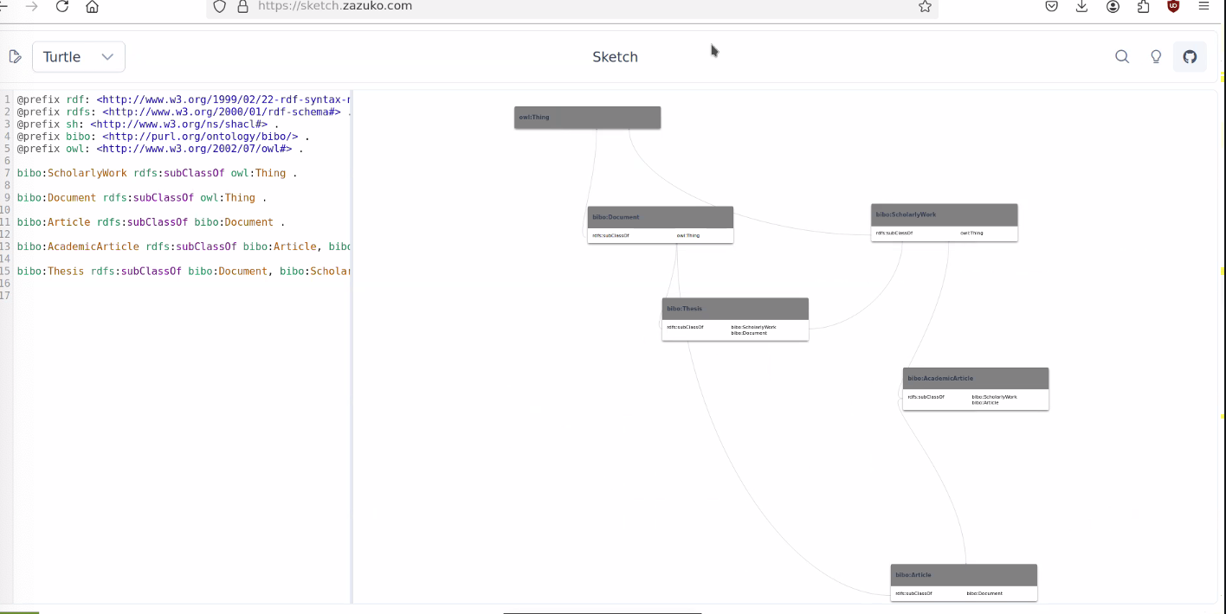
Decisions: possibly - person and organization to DCT; the rest to BIBO
Draft for usage board:
Proposal doc

Any other business
Schedule for next meetings? (We probably won't have a meeting on New Year's Eve…)
- 17 December
- (no meeting on 31 December)
- 14 January, 28 January etc.
- 16:00 UTC

Closure of the meeting

